WEEK 3 PROJECT REPORT
Statistical Analysis and Hypothesis Testing in Python
Statistical Analysis of Retail Sales and Discounts

Submitted by
M. Srivani
Virtual Data Science with Python Apprentice Intern
2026

- Introduction
This project examines whether retail orders with a discount have a different average sales amount from orders without a discount. This question matters to businesses because it can help them understand how sales amounts vary across discounted and non-discounted orders. The analysis tests for a difference between the groups, but it cannot show that discounts cause any difference.
2. Dataset
The dataset file used for this analysis is retail_sales_dataset.csv. It contains retail order information, including sales amount and discount percentage. The analysis uses the sales_amount and discount_pct columns. Rows missing either value were excluded. A discount percentage greater than zero was classified as “Discounted”; a value of zero was classified as “No discount.”
Dataset Source: https://www.kaggle.com/datasets/mohammadtalib786/retail-sales-dataset

3.Hypotheses
Null hypothesis (H₀): The average sales amount is the same for discounted and non- discounted orders.
Alternative hypothesis (H₁): The average sales amount differs between discounted and non-discounted orders.

4. Methodology
The analysis was performed in Python using pandas for data handling, SciPy for the statistical test, and Matplotlib for visualization. Rows missing either sales_amount or discount_pct were removed. Orders with a discount percentage greater than zero were placed in the discounted group; orders with a discount percentage of zero were placed in the no-discount group. The group sizes and descriptive statistics were calculated, and a histogram was created to view the sales amount distributions. Welch’s two-sample t-test was used to compare average sales amounts because it allows the groups to have different variances and sizes. The significance level was set to 0.05.
This test compares group averages. It does not establish that discounts caused any difference in sales.

5. Results
After rows missing sales amount or discount information were removed, the analysis included 4,143 orders: 4,098 discounted orders and 45 orders without a discount. The mean sales amount was 57,082.93 for discounted orders and 500,397.12 for non-discounted orders. The distributions were highly variable, particularly in the much smaller non-discounted group.
Welch’s two-sample t-test gave t(44) = −1.154 and p = 0.255. The estimated mean difference (discounted minus non-discounted) was −443,314.19, with a 95% confidence interval from −1,217,272.46 to 330,644.07. Since the p-value is greater than 0.05 and the interval includes zero, the result is not statistically significant.

Figure 1. Histogram of sales amounts by discount group (logarithmic x-axis).
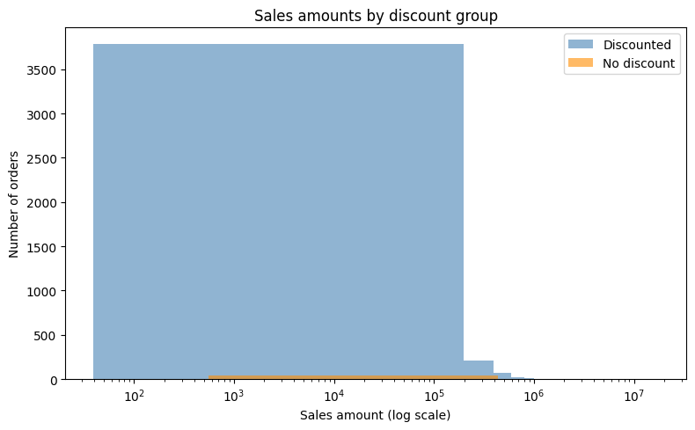

The histogram shows how sales amounts are distributed across discounted and non-discounted orders. Most orders are at the lower end, with a smaller number of very large orders. Because there are far more discounted orders (4,098) than non-discounted orders (45), the discounted group dominates the chart and the smaller group is difficult to see. The horizontal axis uses a logarithmic scale.

Figure 2. Boxplot of sales amounts by discount group, with the largest 2% of values omitted for display.
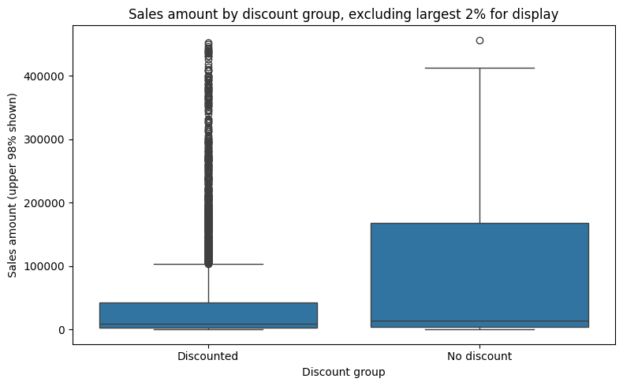
The boxplot compares sales amounts across the two discount groups. The groups differ greatly in size, so the smaller no-discount group is harder to compare visually. The largest 2% of values were excluded from this chart for readability only; all usable rows were included in the statistical test.

6. Conclusion and Limitations
This analysis did not find statistically significant evidence that average sales amounts differ between discounted and non-discounted orders (p = 0.255). Therefore, the null hypothesis was not rejected. This does not prove that the averages are equal. The confidence interval is wide, so the size and direction of the difference remain uncertain.
The comparison has important limitations. Only 45 orders were in the no-discount group, compared with 4,098 discounted orders. Sales amounts were highly variable, and a few very large orders may influence the mean. The dataset may not represent all retail sales, and this observational comparison cannot show that discounts caused sales to change.

7. Python Code

import pandas as pd
import numpy as np
import matplotlib.pyplot as plt
from scipy import stats
from google.colab import files
import os

# 1. Load the CSV
filename = "retail_sales_dataset.csv"

if not os.path.exists(filename):
uploaded = files.upload()
filename = next(iter(uploaded))

df = pd.read_csv(filename)

# 2. Check the dataset
print("Dataset size (rows, columns):", df.shape)
print("Columns:", df.columns.tolist())
print("\nMissing values in analysis columns:")
print(df[["sales_amount", "discount_pct"]].isna().sum())

# 3. Prepare the two groups
analysis_df = df[["sales_amount", "discount_pct"]].dropna().copy()
analysis_df["discount_group"] = np.where(
analysis_df["discount_pct"] > 0,
"Discounted",
"No discount"
)

discounted = analysis_df.loc[
analysis_df["discount_group"] == "Discounted", "sales_amount"
]
no_discount = analysis_df.loc[
analysis_df["discount_group"] == "No discount", "sales_amount"
]

# 4. Show group sizes and descriptive statistics
print("\nGroup sizes:")
print(analysis_df["discount_group"].value_counts())

print("\nSales amount summary by group:")
print(analysis_df.groupby("discount_group")["sales_amount"].agg(
["count", "mean", "median", "std"]
))

# 5. Make a histogram (log scale helps show the highly skewed values)
plt.figure(figsize=(8, 5))
for group, color in [("Discounted", "steelblue"), ("No discount", "darkorange")]:
values = analysis_df.loc[
analysis_df["discount_group"] == group, "sales_amount"
]
plt.hist(values, bins=40, alpha=0.6, label=group, color=color)

plt.xscale("log")
plt.xlabel("Sales amount (log scale)")
plt.ylabel("Number of orders")
plt.title("Sales amounts by discount group")
plt.legend()
plt.tight_layout()
plt.show()

# 6. Create a boxplot excluding the largest 2% for display only
upper_limit = analysis_df["sales_amount"].quantile(0.98)
plot_df = analysis_df[analysis_df["sales_amount"] <= upper_limit]

plt.figure(figsize=(8, 5))
groups = [
plot_df.loc[plot_df["discount_group"] == name, "sales_amount"]
for name in ["Discounted", "No discount"]
]
plt.boxplot(groups, labels=["Discounted", "No discount"])
plt.ylabel("Sales amount (largest 2% omitted from chart)")
plt.title("Sales amount by discount group")
plt.tight_layout()
plt.show()

# 7. Run Welch's two-sample t-test
test_result = stats.ttest_ind(
discounted,
no_discount,
equal_var=False
)

# Calculate mean difference and 95% confidence interval
mean_difference = discounted.mean() - no_discount.mean()
n1, n2 = len(discounted), len(no_discount)
v1, v2 = discounted.var(ddof=1), no_discount.var(ddof=1)
standard_error = np.sqrt(v1 / n1 + v2 / n2)

degrees_freedom = (v1 / n1 + v2 / n2) ** 2 / (
(v1 / n1) ** 2 / (n1 - 1)
+ (v2 / n2) ** 2 / (n2 - 1)
)

critical_value = stats.t.ppf(0.975, degrees_freedom)
ci_low = mean_difference - critical_value * standard_error
ci_high = mean_difference + critical_value * standard_error

# 8. Print the final test results
print("\nWelch's two-sample t-test:")
print(f"Mean difference (discounted - no discount): {mean_difference:,.2f}")
print(f"t-statistic: {test_result.statistic:.3f}")
print(f"Degrees of freedom: {degrees_freedom:.2f}")
print(f"p-value: {test_result.pvalue:.6f}")
print(f"95% confidence interval: [{ci_low:,.2f}, {ci_high:,.2f}]")

